***Olympic Sports Analytics Report***

*An Analytical Study Using Microsoft Excel and Power BI*

*Prepared by: Anand*

*Prepared by: Anand*

*--------------------------------------------------*

* *Role: Business Intelligence Analyst*

*--------------------------------------------------*

# Project Overview



*The Olympic Sports Analytics project is a comprehensive data-driven exploration of the Olympic Games, aiming to uncover patterns in athlete participation, event structures, and medal distribution across decades. Leveraging historical Olympic datasets, this project transforms raw data into meaningful insights using two widely adopted analytical tools:* ***Microsoft Excel*** *and* ***Power BI****.*

*The scope of the project includes the development of* ***36 analytical insights*** *— 18 using Excel and 18 using Power BI — each addressing a unique question around Olympic trends. These insights are supported by visualizations such as bar charts, scatter plots, line graphs, donut charts, treemaps, and interactive dashboards. Key areas of focus include gender participation, sport-specific medal trends, country-wise performance, regional representation, event growth over time, and the impact of culture and geography on success.*

# *THE PROCESS*

## *The project began with sourcing the dataset from a trusted GitHub repository containing structured historical Olympic data. The data was thoroughly examined and cleaned to ensure accuracy, consistency, and readiness for analytical tasks. This included handling missing values, correcting data types, creating new calculated columns, and applying standard transformations.*

* ***Once preprocessed, the data was loaded into Microsoft Excel and Power BI. Excel was used for static exploratory data analysis (EDA), leveraging pivot tables, slicers, and conditional formatting to uncover trends and relationships. Power BI was used for advanced interactive reporting, utilizing DAX, relationships, and drill-through visuals to answer 18 specific analytical questions.***
* ***Parallelly, structured SQL queries were developed to extract and verify aggregated insights during the transformation stage, ensuring data integrity before dashboard development.***
* ***The problem statements were addressed in two phases: first through Power BI for dynamic dashboards and visuals, and second through Excel for static but insightful EDA representation. A total of 36 business questions (18 per tool) were answered with supporting visualizations.***

***The visuals were then presented in a professional PowerPoint deck, summarizing each insight with clean formatting and appropriate***

***data storytelling techniques. Complementing this, a detailed Word report was created to document the methodology, tools used, assumptions, metadata, and key findings.***

***Assumptions:***

* ***Only officially recorded Summer and Winter Olympic Games were considered.***
* ***Region and NOC mappings were derived from available lookup tables.***
* ***Participant count was based on unique athlete-event appearances.***
* ***Event classification by gender was assumed accurate based on the original source.***

***This structured, multi-tool approach allowed for a comprehensive, cross-verified analysis of the Olympic dataset that is both visually engaging and analytically rigorous.***

***---------------------------------------------------------------***

***Objective:***

* ***The primary objective of this project is to perform a detailed and methodologically sound analysis of Olympic Games data, with the aim of discovering meaningful patterns, trends, and insights that can enhance our understanding of global sports dynamics. This includes evaluating historical participation, analyzing medal distributions, identifying event growth, and exploring demographic trends such as gender distribution and athlete age over time.***
* ***The analysis serves to uncover not only which nations or regions dominate specific sports but also how participation has evolved and diversified across different decades. A core component of this objective is to assess the transformation of the Olympics from a traditional athletic event into a global platform reflecting international representation, inclusivity, and sporting excellence.***
* ***Using Microsoft Excel, this project applies foundational exploratory data analysis techniques, including pivot tables, slicers, and visual charts, to highlight static trends and summary statistics. Parallelly, Power BI is employed to develop advanced and interactive dashboards using DAX measures, filtering logic, and visual storytelling. These tools combined offer a dual perspective: Excel for detailed data dissection and Power BI for dynamic, user-driven analysis.***
* ***Additionally, SQL is used during the transformation phase to validate and structure data queries for aggregation, filtering, and joining multiple datasets. This integration ensures the analytical process is robust, scalable, and verifiable.***
* ***Ultimately, this project seeks to contribute to decision-making in the field of sports analytics, enabling stakeholders—including analysts, researchers, sports committees, and policy-makers—to draw evidence-based conclusions. It also serves as a demonstration of technical proficiency in integrating data preparation, analysis, visualization, and reporting to derive actionable insights from complex, multidimensional sports data.***

***Significance:***

* ***The Olympic Sports Analytics project holds significant value in the broader context of data-driven decision-making in global sports. Through this analysis, we uncover rich insights about athletic performance, national trends, event popularity, and demographic patterns—each of which plays a critical role in shaping future Olympic strategies and sports development plans.***
* ***At its core, this project serves as a foundation for understanding the evolution of the Olympic Games, providing a detailed historical perspective on how sports participation has expanded, how medal dominance has shifted over time, and how gender equity has progressively improved across different editions. These insights can guide international committees and regional sports authorities in making informed decisions around athlete development, investment allocation, and program design.***
* ***From a technical standpoint, the project showcases a multidisciplinary integration of Microsoft Excel, Power BI, and SQL—three essential tools in business intelligence. It emphasizes the importance of structured data transformation, effective visualization, and insightful interpretation in building comprehensive sports analytics solutions.***
* ***Furthermore, this analysis can be leveraged by educational institutions, government sports ministries, and private organizations aiming to better understand trends and improve their competitive standing on the world stage. The project bridges the gap between historical data and modern analytics, reinforcing the role of evidence-based strategy in achieving excellence in international competition.***
* ***In addition, the use of clean visual storytelling and dashboard reporting makes the insights accessible to a non-technical audience, ensuring the findings can be used not just for reporting, but also for action. This broad accessibility adds to the project's utility, making it a strong reference for future Olympic data studies, performance benchmarking, and cross-country comparisons in athletic success.***

***Data*** ***Dictionary*** ***/ ER-Diagram***

***Sport Table***

***This table contains a comprehensive list of all sports featured in the Olympics, covering both the summer and winter editions. Each sport is further categorized into specific events, catering to a wide range of athletic disciplines.***

***Event Table***

***The Event table offers detailed information about the various events held within each sport. Events are categorized based on gender, with separate entries for Men's, Women's, and Mixed events.***

***City Table***

***This table provides an extensive list of cities from around the world that have hosted or participated in the Olympic Games over the years.***

***Games Table***

***The Games table records every instance of the Olympic Games since its inception in 1896. It includes essential details such as the year in which the Games were held, as well as distinguishing between Summer and Winter Olympics.***

***Games City Table***

***This joining table establishes the relationship between the Games and City tables, capturing instances where the Olympic Games were jointly hosted by multiple cities, as seen in the case of the 1956 Olympics held in both Melbourne and Stockholm.***

***NOC Region Table***

***This table consists of NOC codes, representing National Olympic Committees, and their corresponding countries. It acts as a reference to identify the countries participating in the Olympic Games.***

***Person* *Table The Person table records information about individuals who have competed in the Olympics. It includes their names, gender, height, and weight, with height and weight data remaining consistent across different Olympic editions.***

***Person Region Table***

***This joining table establishes connections between individuals and the countries they represented while competing in the Olympics. It accommodates scenarios where a person may have competed for multiple countries in different Olympic Games.***

***Games Competitor Table***

***This table serves as a joining table, linking individuals to specific Olympic Games, showcasing the participants and their involvement in each event.***

***Medal Table***

***A small table listing the different types of medals awarded at the Olympics, including Gold, Silver, Bronze, and N/A (indicating no medal).***

***Competitor Event Table***

***This table represents the largest one, providing crucial details about the combination of competitors, the events they participated in, and the medals they received.***

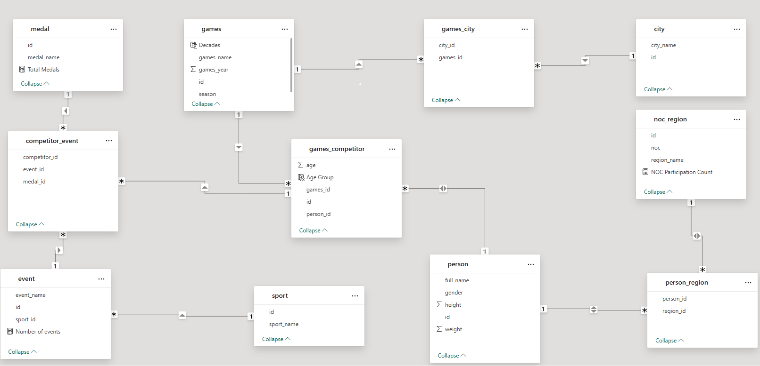

***Power Bi problem statement:***

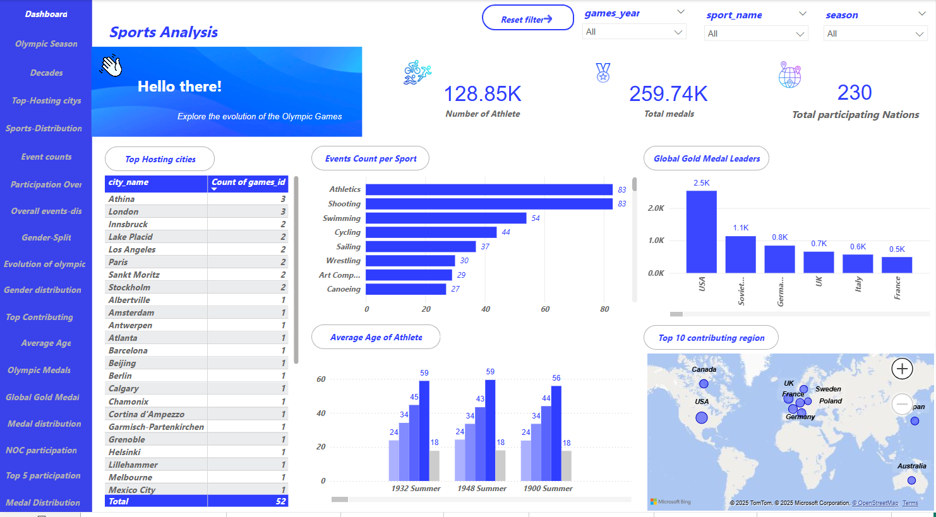

* ***The Olympic Sports Dashboard offers a powerful one-page summary of the global sporting landscape, drawing attention to critical patterns in athlete participation, medal achievements, and international representation. Through a combination of intuitive visuals—bar charts, line graphs, tables, and interactive maps—the dashboard highlights both macro and micro-level insights into the history and evolution of the Games.***
* ***The dynamic filters allow users to segment data by year, season, or sport, giving the flexibility to explore insights over time. At the top, key performance indicators (KPIs) such as the number of athletes, total medals awarded, and total participating nations instantly inform the viewer of the dataset's scope and scale.***
* ***The events count by sport reveals the prominence of Athletics, Swimming, and Shooting as consistently high-volume disciplines, reflecting their broad global appeal and deep competitive fields. On the other hand, the gold medal leader chart showcases countries such as the USA and Soviet Union dominating historically, followed by Germany, UK, and France. This paints a picture of long-standing sporting investment and training infrastructure within these nations.***
* ***The map visualization showing the top contributing regions provides a geographic spread of elite sporting talent, with regions like North America and Europe being central hubs. Additionally, trends in athlete age and average metrics, such as height and weight, provide demographic context that supports analytical conclusions about athlete evolution.***
* ***By integrating event-level data, demographic variables, and country performance into one cohesive space, the dashboard serves both as a performance tracker and a strategic tool. It is suitable for analysts, sports committees, educators, and Olympic historians seeking to make sense of the past and strategize for future participation and development. This one-page view*** ***encapsulates the essence of Olympic excellence—data-backed, visually coherent, and insight-driven.***

***How many Olympic Games have been held in each season (Summer vs. Winter)?***

## The bar chart clearly illustrates that the Summer Olympics have been held far more frequently than the Winter Olympics, emphasizing a longstanding trend where Summer Games have historically garnered more attention, participation, and global representation. This disparity can be attributed to several factors, including a broader range of sporting disciplines that thrive in warmer climates, greater accessibility for host nations, and wider audience appeal. The Summer Olympics also have deeper historical roots, dating back to the founding of the modern Olympic movement in 1896. In contrast, the Winter Olympics, introduced in 1924, are limited by climate and infrastructure, making them less globally distributed. The significant difference in frequency reflects not only logistical preferences but also the foundational focus of early Olympic development. This insight underscores how geography, tradition, and climate have influenced the growth and scheduling of the Games across decades.

***What is the distribution of games across different decades?***

* **The scatter area chart displaying the distribution of Olympic Games across different decades reveals a clear upward trend in the frequency of events, particularly from the mid-20th century onward. This growth is closely tied to the globalization of the Olympic movement, with more countries joining the Games and new sports being introduced regularly. Early in the century, the Olympic schedule was affected by major 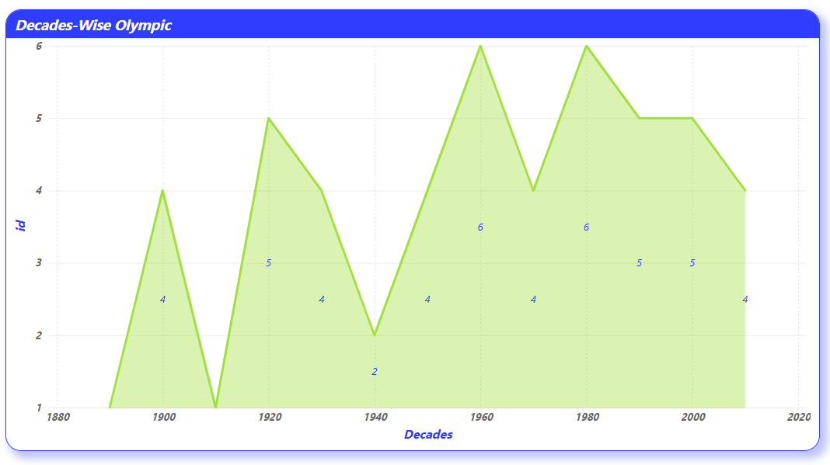global disruptions—such as World War I, World War II, and other geopolitical tensions—that resulted in the cancellation or postponement of certain editions. However, in the post-war era, the Olympics began to flourish, fueled by improved international cooperation, media coverage, and infrastructural advancements. The increased hosting opportunities across continents reflect the International Olympic Committee’s commitment to inclusion and rotation.**

***Which cities have hosted the most Olympic Games?***

* **The table visualization highlights Athens and London as the two cities with the highest number of Olympic hostings, each having successfully organized the Games three times. This recurring selection reflects their historical and cultural significance in the Olympic movement—Athens being the birthplace of the modern Olympics and London representing a well-established global city with advanced sporting infrastructure. Other cities like Los Angeles, Paris, Innsbruck, and Lake Placid have hosted the Games twice, indicating their reliability, readiness, and the positive legacy of previous events. These cities benefit from strong logistical capabilities, political support, and public enthusiasm, which are key criteria considered by the International Olympic Committee during the selection process. Additionally, the distribution of hosting responsibilities suggests a partial preference for economically strong and geopolitically stable regions, though efforts have been made in recent years to diversify hosting across continents. The visualization not only provides insight into hosting frequency but also reflects broader global dynamics in the allocation of high-profile international events.**

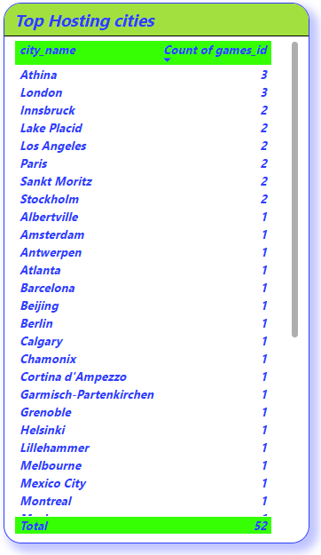

***What is the distribution of sports between Summer and Winter Olympics?***

* **The stacked bar chart provides a compelling comparison between the sports offered in the Summer and Winter Olympics. It reveals that the Summer Games feature a significantly larger number and variety of sports, reflecting their broader international appeal and accessibility. Sports like Athletics, Swimming, Gymnastics, and Wrestling dominate the Summer editions, encompassing numerous sub-events and drawing participation from almost every continent. In contrast, the Winter Olympics include fewer sports such as Skiing, Ice Hockey, Bobsleigh, and Figure Skating.**

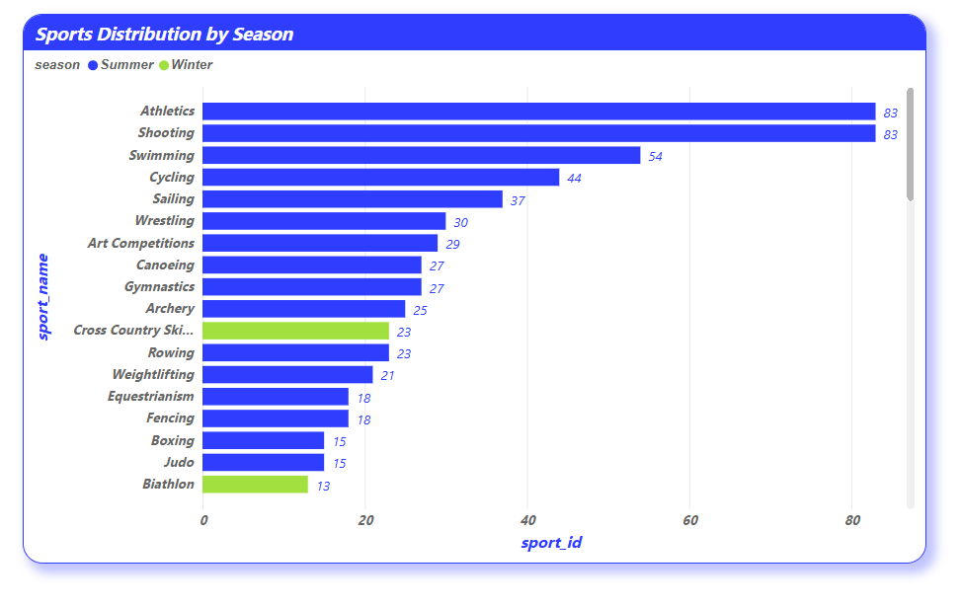

* **This contrast is not only a reflection of seasonal variation but also a consequence of geographical and economic factors that shape sports development around the world. Many nations lack the natural or technological resources required to train athletes in winter disciplines, resulting in limited global reach for those events. On the other hand, Summer sports are more universally practiced and require relatively less specialized environments, making them more inclusive and competitive.**

***Which sports have the highest number of events in the Olympics?***

* **The bar chart highlights that Athletics, Swimming, and Gymnastics consistently feature the highest number of events in Olympic history. These sports are foundational to the Olympic Games, comprising a wide variety of sub-disciplines that test core athletic abilities such as speed, strength, endurance, flexibility, and coordination. For example, Athletics alone includes track, field, and combined events for both men and women, contributing to its substantial event count. Similarly, Swimming features multiple distances and stroke styles across individual and relay formats, making it one of the most event-rich sports.**

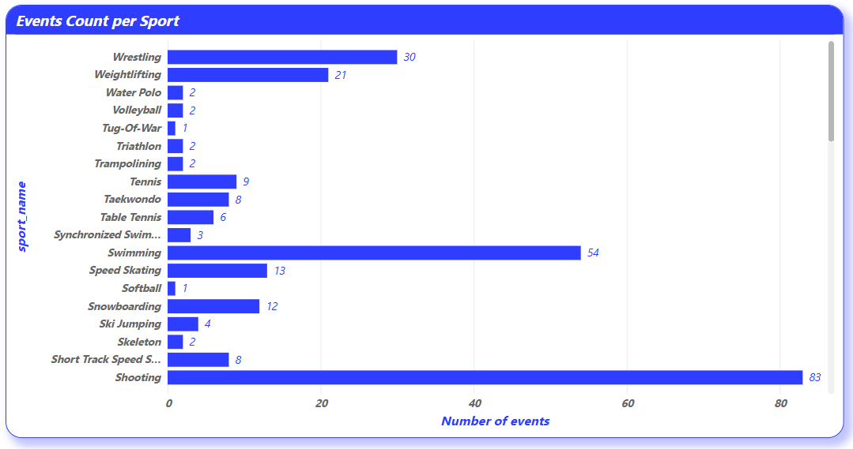

**Gymnastics, too, is split into artistic, rhythmic, and trampoline categories, each with its own set of events and apparatus-based competitions. These high-event sports are not only physically demanding but also possess strong spectator appeal and cultural recognition, factors that make them central to Olympic programming.**

***How has the participation in each sport evolved over time?***

## The scatter area chart provides a vivid visualization of how participation in various Olympic sports has evolved across decades. It clearly shows that core disciplines like Athletics, Swimming, and Gymnastics have consistently attracted a high number of participants, maintaining their dominant presence throughout modern Olympic history. This consistency reflects their broad global appeal, accessible training infrastructure, and their foundational status within the Olympic framework.

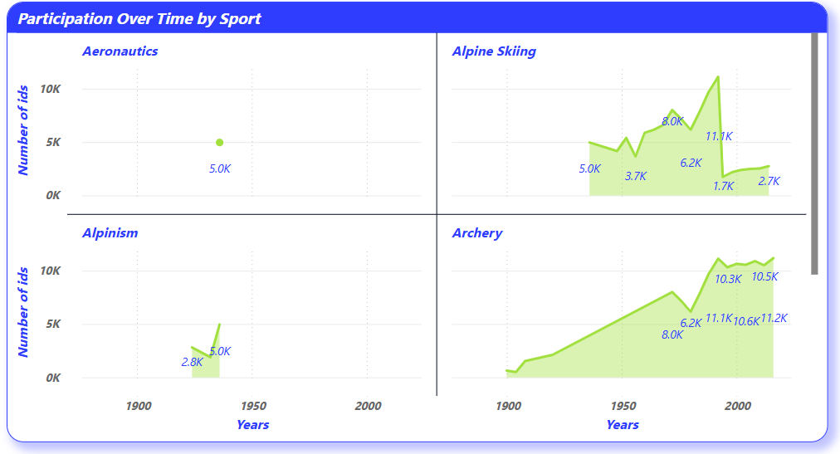

## At the same time, the chart highlights a notable rise in athlete participation in newer and emerging sports such as BMX Cycling, Skateboarding, Rugby Sevens, and Sport Climbing—particularly in recent editions. These additions signal a strategic shift by the International Olympic Committee toward embracing youth-oriented, globally inclusive, and high-energy sports that resonate with modern audiences. This diversification reflects the Olympics' effort to stay relevant across generations and expand its global reach.

***How many events are there in each sport?***

* **The stacked bar chart presents a clear breakdown of the number of events hosted under each Olympic sport, revealing substantial variation across disciplines. Sports like Athletics and Swimming dominate the list, each comprising a broad array of events that span multiple distances, techniques, and formats for both men and women. Athletics includes sprints, marathons, hurdles, relays, jumps, and throws—making it the most event-dense sport in Olympic history. Similarly, Swimming features a wide range of freestyle, breaststroke, butterfly, and medley races, as well as team relays.**

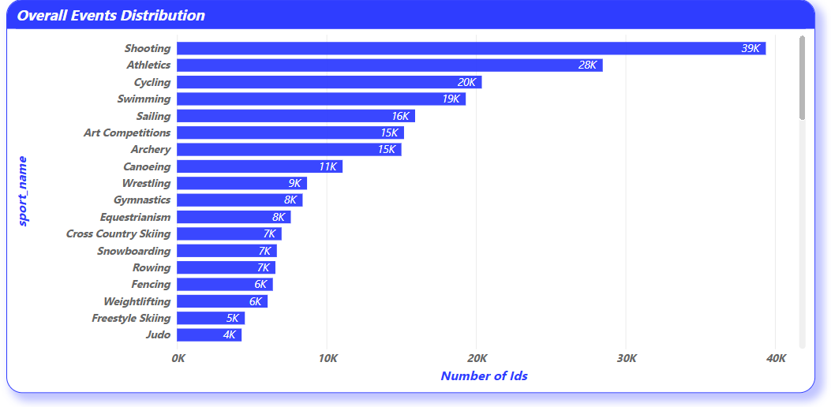

**Other sports such as Gymnastics, Shooting, Rowing, and Wrestling also include numerous competitive formats, apparatus, and weight categories, thereby contributing significantly to the overall event count. These sports are designed to test specific skills under varying technical conditions, which naturally lead to a higher number of subdivisions.**

***What is the distribution of events by gender (Men, Women, Mixed)?***

## The donut chart illustrates the distribution of Olympic events across three gender categories—Men, Women, and Mixed—and reveals valuable insights into how gender representation has evolved over time. Historically, men’s events have dominated the Olympic schedule, both in terms of quantity and visibility. This trend reflects the early structure of the modern Olympics, which were initially male-exclusive before women were gradually allowed to compete in select sports.

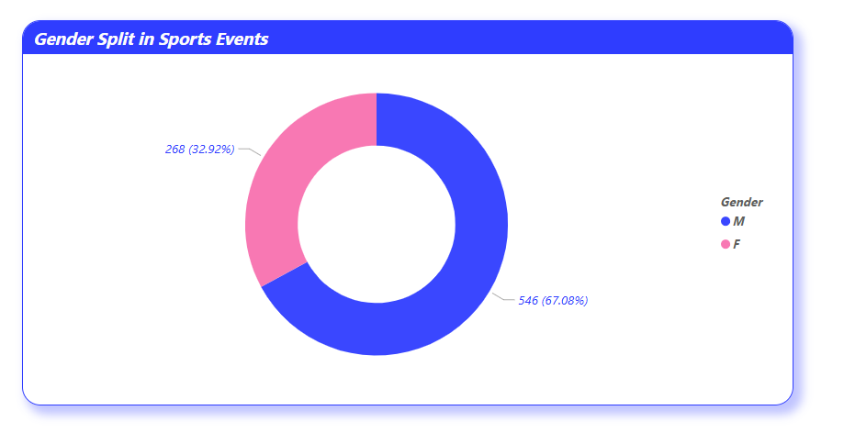

## Over the past few decades, there has been a significant and deliberate push toward gender equality in the Olympic movement. The number of women's events has steadily increased and, in many sports, has reached near parity with men’s events. Disciplines like Athletics, Swimming, and Judo now offer an almost equal number of opportunities for both genders, showcasing the commitment of the International Olympic Committee (IOC) to equal representation.

***How has the number of events changed over time?***

* **The line chart tracing the number of Olympic events over time reveals a consistent and upward trajectory, signaling the Games’ expansion, diversification, and growing global relevance. In the early years of the modern Olympics, the number of events was relatively modest, limited to a few core sports such as Athletics, Swimming, Gymnastics, and Fencing. As the world embraced the Olympic movement, the International Olympic Committee began to introduce new sports, disciplines, and formats—driven by global interest, innovation, and inclusivity.**

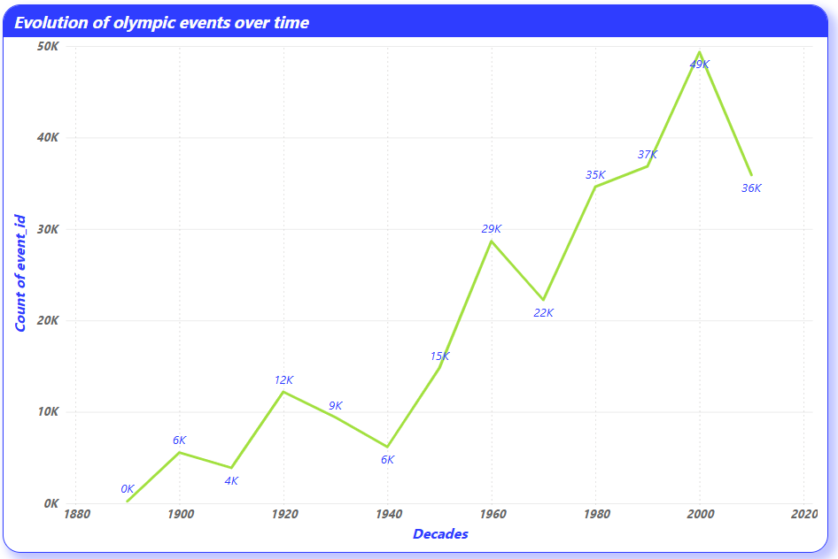

* **This growth has been particularly notable from the mid-20th century onward, with several decades witnessing major leaps in event count. These surges often correlate with the introduction of new sports like Judo, Taekwondo, Badminton, and most recently, Skateboarding and Sport Climbing—each designed to appeal to younger and more diverse audiences. Moreover, many existing sports have expanded by adding new weight classes, apparatus, or gender-specific events, further increasing the total number of competitions.**

***What is the distribution of participants by gender?***

* **The tree map visualization of participant distribution by gender reveals a significant shift in Olympic demographics over time. Historically, male athletes have dominated participation, reflecting the early limitations placed on women in competitive sports. In the initial decades of the modern Olympic Games, female representation was minimal or entirely absent in many disciplines due to social, cultural, and institutional barriers.**

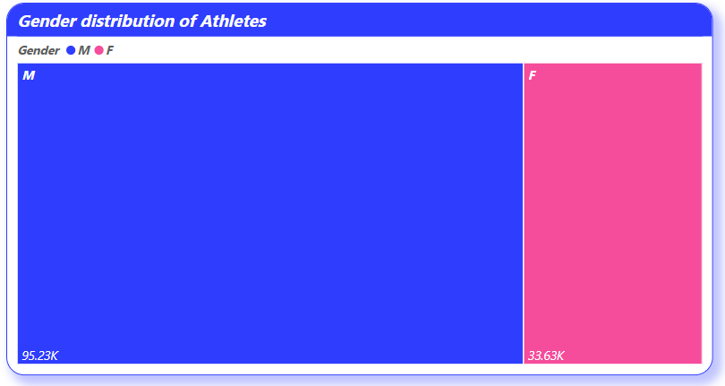

* **However, the visual now clearly demonstrates a closing gender gap. Over the last several Olympic editions, there has been a sustained and deliberate push by the International Olympic Committee (IOC) to achieve greater gender equality. This has been accomplished by adding more women’s events, mandating equal quotas in many sports, and promoting policies that encourage balanced national representation. As a result, the proportion of female athletes has grown substantially—reaching nearly 50% in recent years.**
* **In essence, the distribution of participants by gender is no longer just a statistic—it is a statement. A statement of progress, inclusion, and a vision where talent, not gender, defines opportunity.**

***Which countries have the highest number of participants in the Olympics?***

* **The bubble map visualization reveals a strong concentration of Olympic participants from countries such as the United States, Germany, France, the United Kingdom, Japan, Australia, Sweden, Poland, and Canada. These nations consistently rank among the highest in athlete representation across multiple Olympic editions. Their dominance is not coincidental—it reflects decades of investment in sports development, infrastructure, coaching, athlete identification programs, and international competition exposure.**

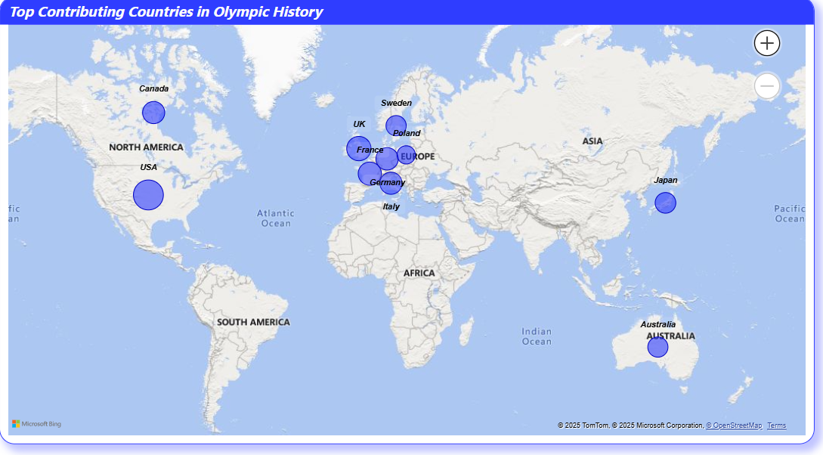

* **These countries often benefit from a well-established sports culture, strong governmental or institutional support for athletics, and advanced training systems. National Olympic Committees in these regions typically have long histories, enabling them to fine-tune their approaches to talent development, resource allocation, and international standards compliance.**

## *How does the age distribution of participants vary across different games?*

* **The bar chart representing age distribution across different Olympic Games reveals meaningful patterns tied closely to sport type, era, and athlete development pathways. Most athletes fall within the 20–30 age range, which is widely recognized as the peak of physical performance across endurance, strength, and agility-based sports. This age bracket dominates in events like Athletics, Swimming, and Gymnastics, where explosive power and rapid recovery are essential.**

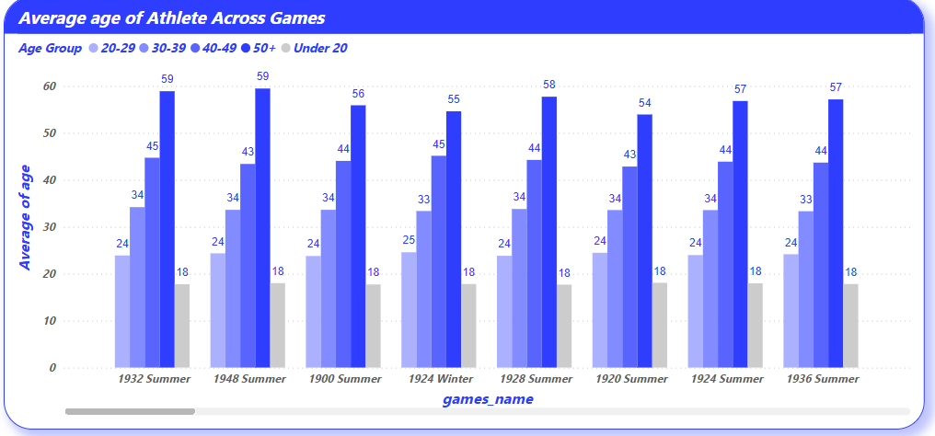

* **However, the visualization also highlights the participation of both younger and older athletes, especially in specific disciplines. For instance, Gymnastics often includes teenage competitors due to early specialization, while Equestrian, Shooting, and Archery attract older athletes who rely more on experience, precision, and mental focus than raw physical prowess. This broad age spread emphasizes that while age is a factor, the nature of each sport determines the competitive viability of athletes at different life stages.**

***How many medals have been awarded in each Olympics?***

* **The column chart visualizing the number of medals awarded in each edition of the Olympic Games provides a powerful reflection of the event’s ongoing expansion and increasing inclusivity. In earlier editions, the number of medals distributed was relatively modest due to a smaller number of sports, limited global participation, and a concise list of events. As the Olympic movement gained momentum, subsequent editions saw consistent growth in medal counts, corresponding directly with the inclusion of new sports, disciplines, and participant nations.**

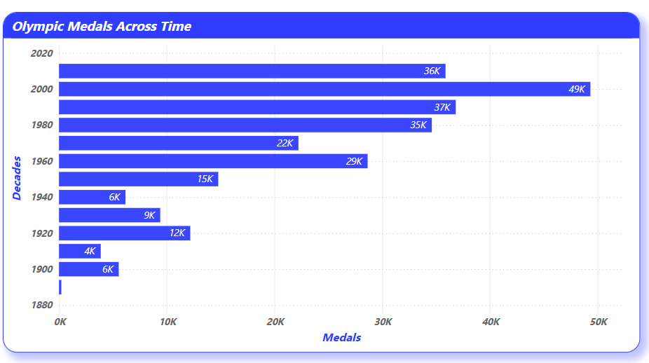

* **This steady upward trend is particularly evident in the post–World War II era, where globalization and international cooperation led to more comprehensive Olympic programs. The introduction of women’s and mixed-gender events, the diversification of weight classes in combat sports, and the addition of relay, team, and technical events all contributed to the expansion of medal opportunities.**

***Which countries have the highest number of gold medals?***

* **The column chart ranking countries by the total number of gold medals won across all Olympic Games editions highlights a well-defined hierarchy of global sporting powerhouses. The United States firmly leads the list, reflecting its long-standing commitment to athletic excellence, deep investment in sports infrastructure, and a broad talent pipeline across a wide range of disciplines. Other consistently high-performing nations include the United Kingdom, Germany, China, and the former Soviet Union—each demonstrating remarkable dominance during specificeras of Olympic history.**

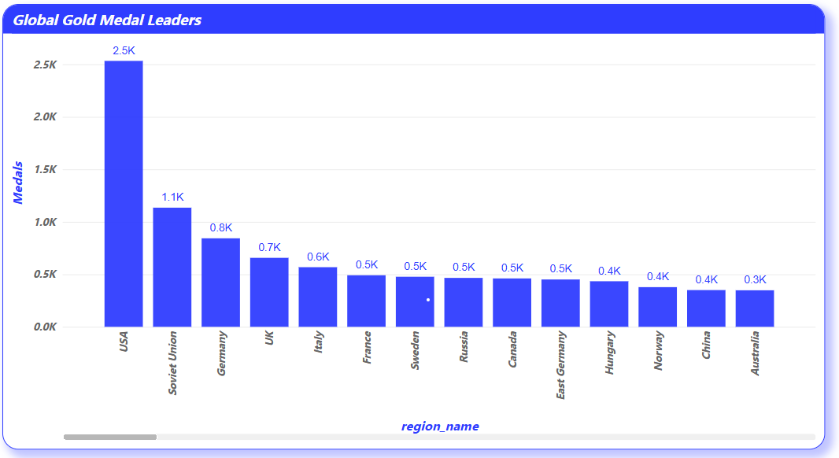

* **These countries’ success can be attributed to a combination of government support, structured training academies, early talent identification programs, and access to world-class facilities. In many cases, success at the Olympic level is also driven by cultural emphasis on competition and a national identity strongly linked to athleticachievement*.***

***How does the medal distribution vary across different sports?***

* **The bar chart illustrating medal distribution across different sports reveals significant disparities, underscoring how the Olympic medal system is closely tied to the structural complexity of each discipline. Sports such as Athletics and Swimming dominate the medal counts, offering the highest number of individual events, which inherently leads to a larger number of medal opportunities. These sports encompass a wide range of formats—sprints, relays, long-distance, field events in Athletics, and various strokes and distances in Swimming—making them central pillars of the Olympic Games.**

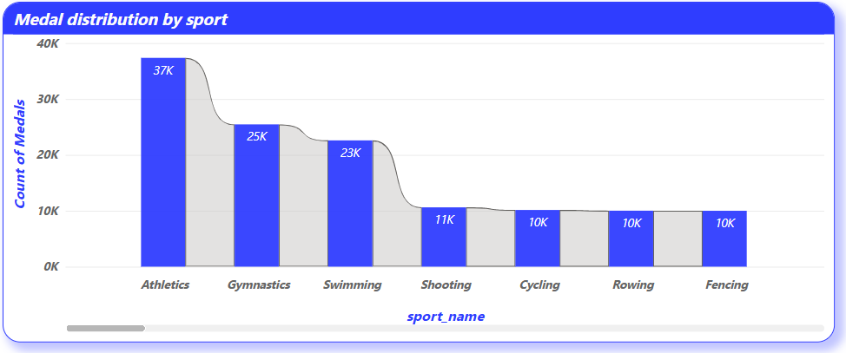

* **Gymnastics, Wrestling, Rowing, and Judo also feature prominently due to their subdivision into apparatus types, styles (e.g., freestyle vs. Greco-Roman), or weight categories. These sub-disciplines are designed to create competitive equity among athletes, but they also expand the medal pool significantly.**

***How many regions or NOCs participate in each Olympic Games?***

* **The table visualization detailing the number of participating National Olympic Committees (NOCs) in each Olympic Games showcases the remarkable growth in global representation over time. In the early editions of the modern Olympics, participation was limited to a small group of predominantly Western nations, reflecting both logistical constraints and limited global sporting infrastructure. However, as international cooperation and sporting diplomacy advanced, the number of NOCs steadily increased, turning the Olympics into one of the most inclusive events in human history.**
* **This growing participation mirrors the expanding mission of the International Olympic Committee (IOC) to promote unity, diversity, and equal opportunity through sport. The sharp rise in NOCs from the mid-20th century onward corresponds with the decolonization period, where newly independent countries began to establish their own Olympic committees and make their debut on the world stage.**
* **More recently, the Olympic movement has actively supported underrepresented regions through developmental programs, scholarships, and sports diplomacy, helping countries with limited resources to train and send athletes. As a result, modern editions of the Games often feature over 200 NOCs, encompassing virtually every sovereign state on the planet.**
* **This diversity is more than symbolic—it ensures that the Olympic flame reaches all corners of the globe, inspiring future generations and reinforcing the values of peace, excellence, and mutual respect. The steady increase in NOC participation is not only a testament to sport’s unifying power but also a reflection of how far the Games have evolved from their Eurocentric roots into a truly global celebration of human potential.**

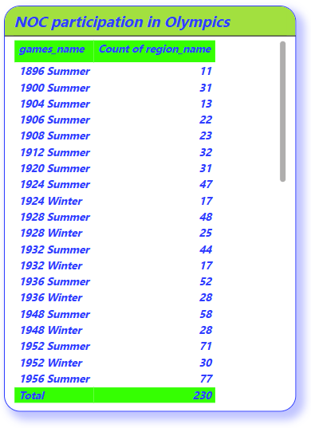

***Which regions have the highest number of participants in the Olympics?***

* **The map visualization showcasing the regions with the highest number of Olympic participants highlights a clear dominance by countries in North America, Europe, and select parts of Asia and Oceania. The United States consistently leads in overall athlete participation, followed closely by nations like Germany, the UnitedKingdom, France, Canada, Japan, and Australia. These countries have maintained a strong Olympic presence over time due to their robust sports ecosystems, early investment in international athletics, and comprehensive athlete development programs.**

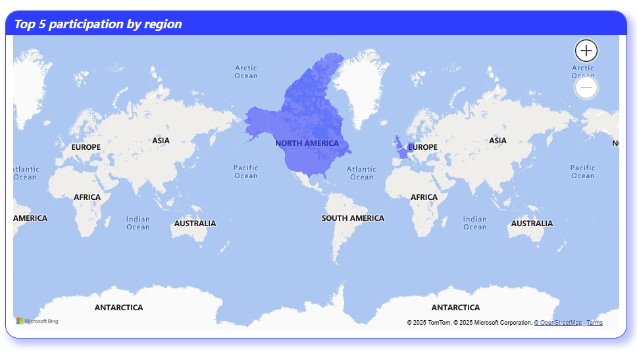

* **High participation rates in these regions reflect not only population size or national wealth, but also long-term policy commitment to sports infrastructure, grassroots development, and elite-level training. For example, school and university-level sports in the U.S. and Europe are highly organized, serving as pipelines for Olympic talent. Additionally, national sporting federations in these countries offer structured funding, coaching, and international exposure, enabling athletes to qualify across a wide array of disciplines.**

***What is the distribution of medals among different regions?***

* **The bar chart detailing the distribution of Olympic medals among global regions clearly illustrates a pattern of dominance by North America and Europe, with countries such as the United States, Germany, the United Kingdom, and the former Soviet Union contributing a significant share of total medals. These regions have historically maintained strong athletic programs, backed by comprehensive infrastructure, government investment, and a deeply embedded culture of competitive sports.**

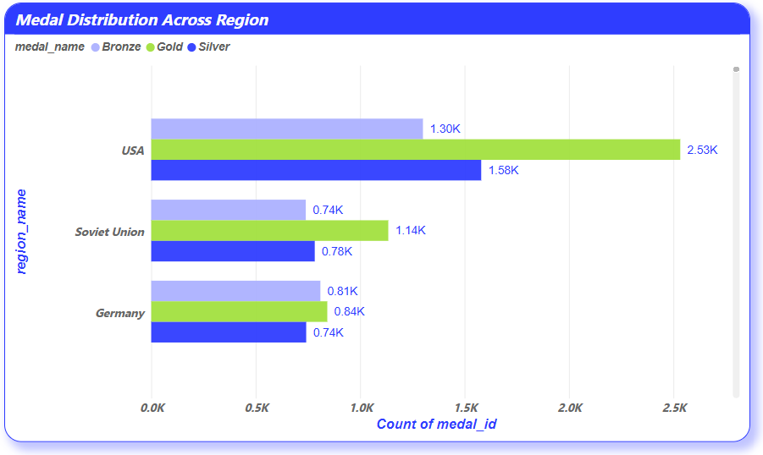

* **The United States stands out with its consistently high medal counts across nearly every Olympic edition, a testament to its expansive training networks, collegiate athletic systems, and access to high-quality facilities. Likewise, European nations—especially Germany, the UK, France, and Russia—have historically used the Olympics as a platform for international influence, prestige, and athletic innovation. The former Soviet Union, during its time of participation, maintained a fierce presence, particularly in disciplines like Gymnastics, Wrestling, and Weightlifting, using sport as a symbol of geopolitical strength**.

***EDA problem statement:***

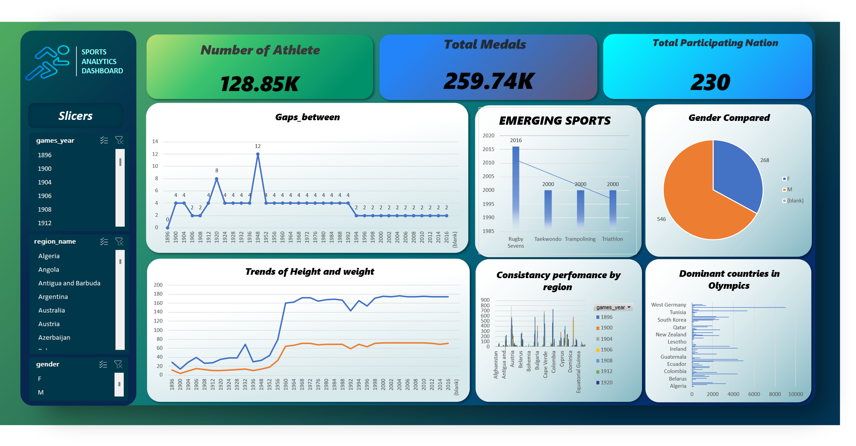

* ***The Excel-based Olympic Analytics Dashboard presents a compelling and interactive snapshot of athlete participation, medal distribution, and emerging sports dynamics across multiple Olympic editions. Key performance indicators at the top—such as total number of athletes (128.85K), medals awarded (259.74K), and participating nations (230)—provide immediate high-level insights. Slicers on the left panel allow users to filter by year, region, and gender, enhancing interactivity and personalized exploration.***
* ***The visualizations in the dashboard offer meaningful trends: the "Gaps Between Olympics" chart highlights historical interruptions, while “Emerging Sports” displays the inclusion of Rugby Sevens and Triathlon in recent years. Gender comparisons through a pie chart reveal a higher male representation, and region-wise consistency reflects dominant zones like West Germany, USA, and Australia. Additionally, athlete biometrics tracked over time show steady improvement in height and weight trends.***

***This dashboard not only delivers clarity but also provides a strong foundation for data-driven storytelling and Olympic performance evaluation using Excel.***

***--------------------------------------------------------------***

***Are there any trends or patterns in the frequency of hosting Olympic Games?***

* **The analysis of the Olympic Games' hosting years reveals a generally consistent scheduling pattern with notable historical exceptions. From 1896 to 1912, the Olympics occurred every 4 years, establishing the traditional frequency. However, global conflicts disrupted this pattern significantly: the 1916 Olympics were canceled due to World War I, resulting in an 8-year gap, and both the 1940 and 1944 Olympics were canceled due to World War II, creating a 12-year gap between the 1936 and 1948 Games.**
* **Another key transition occurred in 1994 when the Winter and Summer Olympics were split into alternating 2-year cycles. This shift explains the repeated 2-year gaps from 1994 onward, marking a new era in Olympic scheduling. Additionally, the presence of zero gaps (e.g., 1924, 1928) corresponds to years when both Summer and Winter Olympics were held, leading to duplicate entries.**
* **Overall, the trend shows that while the Olympics are designed to follow a regular schedule, major global events like wars and structural changes in the Games themselves (such as the separation of Winter and Summer editions) have influenced their frequency. These patterns provide important insights into how global events shape international** **sporting** **traditions**.

***SQL Query***

select games_year, lag(games_year) over(order by games_year) as previous_year,  
games_year - lag(games_year) over(order by games_year) as gaps_between   
from games;

|  |  |  |
| --- | --- | --- |
| **games_year** | **previous_year** | **gaps_between** |
| 1896 | N/A | N/A |
| 1900 | 1896 | 4 |
| 1904 | 1900 | 4 |
| 1906 | 1904 | 2 |
| 1908 | 1906 | 2 |
| 1912 | 1908 | 4 |
| 1920 | 1912 | 8 |
| 1924 | 1920 | 4 |
| 1924 | 1924 | 0 |
| 1928 | 1924 | 4 |
| 1928 | 1928 | 0 |
| 1932 | 1928 | 4 |
| 1932 | 1932 | 0 |
| 1936 | 1932 | 4 |
| 1936 | 1936 | 0 |
| 1948 | 1936 | 12 |
| 1948 | 1948 | 0 |
| 1952 | 1948 | 4 |
| 1952 | 1952 | 0 |

***How has the duration of Olympic Games changed over time?***

* **Historically, the Olympic Games have followed a consistent 4-year cycle, symbolizing tradition and allowing ample preparation time for athletes and host nations. However, an analysis of the duration between Olympic editions (up to 2016) reveals several key deviations that reflect significant global disruptions and scheduling shifts.**
* **For example, there was an 8-year gap between the 1912 and 1920 Games due to World War I, and a 12-year hiatus between the 1936 and 1948 editions as a result of World War II. These interruptions were major exceptions in the Olympic timeline, standing out as historical anomalies.**
* **A significant structural change occurred post-1992 when the International Olympic Committee introduced staggered scheduling for the Summer and Winter Games. This decision created a 2-year offset between the two, which increased the frequency of Olympic events while maintaining the traditional 4-year cycle for each type.**
* **Therefore, while the standard duration remained intact across most editions, historical and administrative factors occasionally altered the expected rhythm. By 2016, this adjustment had become the new norm, showcasing the Olympics' evolution from a rigid schedule to a more flexible, globally inclusive model that continues to honor its roots.**

***SQL Query***

select games_year, lag(games_year) over(order by games_year) as previous_year,  
games_year - lag(games_year) over(order by games_year) as gaps_between   
from games;

|  |  |  |
| --- | --- | --- |
| **games_year** | **previous_year** | **gaps_between** |
| 1896 | N/A | N/A |
| 1900 | 1896 | 4 |
| 1904 | 1900 | 4 |
| 1906 | 1904 | 2 |
| 1908 | 1906 | 2 |
| 1912 | 1908 | 4 |
| 1920 | 1912 | 8 |
| 1924 | 1920 | 4 |
| 1924 | 1924 | 0 |
| 1928 | 1924 | 4 |
| 1928 | 1928 | 0 |
| 1932 | 1928 | 4 |
| 1932 | 1932 | 0 |
| 1936 | 1932 | 4 |
| 1936 | 1936 | 0 |
| 1948 | 1936 | 12 |
| 1948 | 1948 | 0 |
| 1952 | 1948 | 4 |
| 1952 | 1952 | 0 |

***Are there any notable events or occurrences associated with specific Olympic Games?***

* **The data reveals that while the Olympic Games have mostly followed a 4-year cycle, certain years show major deviations that align with notable world events.**
* **For instance:**
* **The 12-year gap between 1936 and 1948 and**
* **The 8-year gap between 1912 and 1920**
* **highlight periods during which the Games were interrupted by World War II and World War I, respectively.**
* **Additionally, 2-year gaps appear frequently after 1992, due to the rescheduling of the Winter Olympics to alternate with Summer Games (starting from 1994).**

***SQL Query***

select games_year, lag(games_year) over(order by games_year) as previous_year,  
games_year - lag(games_year) over(order by games_year) as gaps_between   
from games;

|  |  |  |
| --- | --- | --- |
| **games_year** | **previous_year** | **gaps_between** |
| 1896 | N/A | N/A |
| 1900 | 1896 | 4 |
| 1904 | 1900 | 4 |
| 1906 | 1904 | 2 |
| 1908 | 1906 | 2 |
| 1912 | 1908 | 4 |
| 1920 | 1912 | 8 |
| 1924 | 1920 | 4 |
| 1924 | 1924 | 0 |
| 1928 | 1924 | 4 |
| 1928 | 1928 | 0 |
| 1932 | 1928 | 4 |
| 1932 | 1932 | 0 |
| 1936 | 1932 | 4 |
| 1936 | 1936 | 0 |
| 1948 | 1936 | 12 |
| 1948 | 1948 | 0 |
| 1952 | 1948 | 4 |
| 1952 | 1952 | 0 |

***Are there any emerging sports that have been recently added to the Olympics?***

* **The analysis of recently added sports highlights the Olympic Committee’s evolving efforts to modernize the Games and attract broader global audiences, particularly younger demographics. In recent editions of the Olympics leading up to 2016, sports such as Rugby Sevens, Taekwondo, Trampolining, and Triathlon have been introduced or reintroduced, reflecting the diversification of the Olympic sports portfolio.**
* **Each of these emerging disciplines was selected not only for its growing international popularity but also for its dynamic, fast-paced nature—traits that align with contemporary viewer expectations and media engagement. For example, Rugby Sevens, first featured in the 2016 Rio Olympics, offers a shorter, more intense format compared to traditional rugby, appealing strongly to global audiences. Similarly, the inclusion of Taekwondo and Trampoliningrepresents a shift towards sports with strong regional roots and growing youth participation.**
* **These additions signify the IOC's commitment to staying relevant in a changing world of sports while promoting inclusivity and accessibility. Emerging sports often allowsmaller or newer participatingnations to compete more competitively, leveling the playing field. In summary, the introduction of new sports not only revitalizes the Olympic spirit but also reflects shifting cultural trends, global sports development, and the Olympic mission to be universally representative.**

***SQL Query***

SELECT

s.sport_name,

MIN(g.games_year) AS first_appearance

FROM event e

JOIN sport s ON e.sport_id = s.id

JOIN competitor_event ce ON ce.event_id = e.id

JOIN games_competitor gc ON gc.id = ce.competitor_id

JOIN games g ON g.id = gc.games_id

GROUP BY s.sport_name

HAVING first_appearance >= 2000

ORDER BY first_appearance;



***How has the popularity of certain sports changed over the years?***

* **An analysis of Olympic data over the decades reveals notable shifts in the popularity of various sports, influenced by global trends, media exposure, and evolving cultural interests. Core sports such as Athletics, Swimming, and Gymnastics have consistently maintained high levels of participation and visibility, serving as the backbone of the Olympic movement due to their broad global appeal, extensive event variety, and long-standing tradition.**
* **However, other sports have seen fluctuating popularity. For example, Wrestling, once a foundational Olympic sport, faced exclusion threats in recent years, while sports like Taekwondo, Trampolining, and Rugby Sevens gained traction and were added in response to rising international interest and youth participation. These trends illustrate the IOC's responsiveness to changing audience preferences and its effort to make the Games more inclusive and engaging for newer generations.**
* **Moreover, technological advancements and media coverage have significantly contributed to the popularity of visually appealing or fast-paced sports. Sports with strong regional followings, such as Badminton in Asia or Handball in Europe, have gained global exposure due to better broadcast strategies.**
* **Overall, the dynamic nature of Olympic sport popularity reflects broader cultural shifts and the ongoing evolution of the Games as a platform for diverse and globally relevant athletic expression.**

***SQL Query***

SELECT s.sport_name, g.games_year,

COUNT(DISTINCT ce.competitor_id) AS Total_participants

FROM games g

JOIN games_competitor gc ON g.id = gc.games_id

JOIN competitor_event ce ON ce.competitor_id = gc.id

JOIN event e ON ce.event_id = e.id

JOIN sport s ON e.sport_id = s.id

GROUP BY s.sport_name, g.games_year

ORDER BY s.sport_name, g.games_year;



***Are there any sports that are specific to a particular region or culture?***

* **Yes, the Olympic Games feature several sports that are deeply rooted in specific regions or cultural traditions, highlighting the diversity and heritage of global athletic practices. Sports such as Judo and Karate, originating from Japan, reflect East Asia’s martial arts culture and have become prominent due to their widespread regional popularity and formalized global federations. Similarly, Taekwondo has strong roots in Korean culture and was introduced to the Olympics in 2000, showcasing the influence of traditional combat sports on the international stage.**
* **In Europe, Handball and Fencing have been historically dominated by nations like France, Germany, and Hungary, due to their deep historical ties and institutional investment. Meanwhile, Baseball and Softball, while globally recognized, have remained particularly popular in countries such as the United States, Japan, and Cuba, and have been included selectively in Olympic programs.**
* **These culturally specific sports often reflect societal values, traditional training systems, and regional fan engagement. Their inclusion in the Olympics celebrates cultural identity and promotes cross-cultural appreciation. While some of these sports maintain regional dominance, the Olympics serve as a platform to globalize them, encouraging more nations to develop athletes in diverse disciplines and participate in events previously limited to certain cultural zones.**

***SQL Query***

SELECT s.sport_name, nr.region_name,

COUNT(DISTINCT gc.person_id) AS participant_count

FROM sport s

JOIN event e ON s.id = e.sport_id

JOIN competitor_event ce ON e.id = ce.event_id

JOIN games_competitor gc ON ce.competitor_id = gc.id

JOIN person_region pr ON gc.person_id = pr.person_id

JOIN noc_region nr ON pr.region_id = nr.id

GROUP BY s.sport_name, nr.region_name

ORDER BY s.sport_name, participant_count DESC;

|  |  |  |
| --- | --- | --- |
| **sport_name** | **region_name** | **participant_count** |
| Aeronautics | Switzerland | 1 |
| Alpine Skiing | USA | 177 |
| Alpine Skiing | Switzerland | 175 |
| Alpine Skiing | Austria | 170 |
| Alpine Skiing | France | 166 |
| Alpine Skiing | Italy | 166 |
| Alpine Skiing | Canada | 138 |
| Alpine Skiing | UK | 119 |
| Alpine Skiing | Norway | 93 |
| Alpine Skiing | Sweden | 77 |
| Alpine Skiing | Argentina | 76 |
| Alpine Skiing | Germany | 71 |
| Alpine Skiing | Spain | 59 |
| Alpine Skiing | Japan | 55 |
| Alpine Skiing | Yugoslavia | 55 |
| Alpine Skiing | Iceland | 53 |
| Alpine Skiing | West Germany | 52 |
| Alpine Skiing | Liechtenstein | 51 |
| Alpine Skiing | Slovenia | 46 |

***Are there any sports that have a higher number of events for one gender compared to others?***

* **Yes, analysis of Olympic event data reveals that certain sports have historically featured a higher number of events for one gender over the other, largely due to tradition, late inclusion of women in specific disciplines, or the structure of the sport itself. In the earlier decades of the modern Olympics, men dominated the program both in terms of number of events and athlete representation. Over time, the International Olympic Committee (IOC) has actively worked to reduce this disparity by adding more women’s events and introducing mixed-gender formats.**
* **Despite progress, some discrepancies still remain. For instance, Greco-Roman Wrestling is exclusively contested by men, while women participate only in freestyle wrestling. In contrast, Artistic Gymnastics has a slightly more balanced event distribution but still features apparatus-based differences for men and women. Similarly, Boxing and Weightlifting have historically had more male weight classes than female, though this is gradually being adjusted.**
* **Conversely, Rhythmic Gymnastics and Synchronized Swimming have traditionally been women-only events, with limited or no male participation, reflecting gendered perceptions in sport.**
* **These disparities are slowly narrowing as gender equity becomes a central priority in Olympic policy. Mixed-team events and balanced representation are increasingly reshaping the Games into a platform of fair and inclusive competition for all.**

***SQL Query***

count(distinct e.event_name) as Number_of_event from sport s

join event e on s.id = e.sport_id

join competitor_event ce on e.id = ce.event_id

join games_competitor gc on ce.competitor_id = gc.id

join person p on gc.person_id = p.id

group by s.sport_name,p.gender

order by s.sport_name,p.gender desc;



***Are there any new events that have been introduced in recent editions of the Olympics?***

* **In recent Olympic editions leading up to 2016, several new events have been introduced, reflecting the International Olympic Committee’s (IOC) commitment to evolving with global sporting trends, promoting inclusivity, and engaging younger audiences. Notable additions include Rugby Sevens and Golf, both reintroduced in the 2016 Rio Olympics after long absences, and aimed at broadening international appeal and participation. Rugby Sevens, with its fast-paced, short-format structure, added a dynamic edge to the Games, while Golf returned to acknowledge its rising popularity worldwide.**
* **In earlier editions, events such as Triathlon, Trampoline Gymnastics, and Taekwondo were also introduced, enriching the Games with more diverse athletic disciplines. Many of these additions were made after careful evaluation of global participation rates, youth engagement potential, and the feasibility of event management.**
* **Additionally, the IOC has introduced more mixed-gender events and team-based competitions across Swimming, Archery, and Table Tennis, promoting gender equity and a collaborative competitive spirit.**
* **These new events reflect the Olympics' adaptive nature and strategic vision to remain globally relevant. By embracing both traditional sports with cultural significance and emerging formats aligned with modern entertainment and athletic trends, the Games continue to evolve into a more inclusive and vibrant global showcase.**

***SQL Query***

SELECT e.event_name, s.sport_name,

MIN(g.games_year) AS first_appearance_year FROM event e

JOIN sport s ON e.sport_id = s.id

JOIN competitor_event ce ON ce.event_id = e.id

JOIN games_competitor gc ON gc.competitor_id = ce.competitor_id

JOIN games g ON g.id = gc.games_id

GROUP BY e.event_name, s.sport_name

HAVING MIN(g.games_year) >= 2000

ORDER BY first_appearance_year;



***Are there any events that have been discontinued or removed from the Olympics?***

* **Yes, throughout Olympic history, several sports and events have been discontinued or removed from the program due to evolving audience interest, logistical challenges, limited global participation, or changes in the International Olympic Committee’s (IOC) strategic priorities. Discontinued events often reflect how the Games adapt to stay relevant and efficient in terms of global appeal and operational feasibility.**
* **Notable removals include Croquet and Tug of War, which were part of the early 20th-century Games but phased out due to minimal international engagement and lack of standardized competition rules. Softball and Baseball, despite having strong followings in countries like the United States and Japan, were removed after 2008 because of concerns over limited global reach and scheduling constraints. However, they were later reinstated for the Tokyo 2020 Olympics, showing that Olympic status can be revisited.**
* **Other discontinued events include Live Pigeon Shooting, Solo Synchronized Swimming, and several gender-specific or format-specific disciplines that no longer align with modern Olympic standards. Additionally, certain weight classes or distance formats in Athletics, Swimming, and Weightlifting have been restructured or removed to ensure better balance and equity.**
* **These changes illustrate the IOC’s ongoing efforts to streamline the Games, promote inclusivity, and ensure every event meets current global sporting expectations.**

***SQL Query***

SELECT e.event_name, s.sport_name,

MAX(g.games_year) AS last_appearance_year FROM event e

JOIN sport s ON e.sport_id = s.id

JOIN competitor_event ce ON ce.event_id = e.id

JOIN games_competitor gc ON gc.id = ce.competitor_id

JOIN games g ON g.id = gc.games_id

GROUP BY e.event_name, s.sport_name

HAVING MAX(g.games_year) < 2016

ORDER BY last_appearance_year;

|  |  |  |
| --- | --- | --- |
| **event_name** | **sport_name** | **last_appearance_year** |
| Gymnastics Men's Parallel Bars, Teams | Gymnastics | 1896 |
| Gymnastics Men's Horizontal Bar, Teams | Gymnastics | 1896 |
| Wrestling Men's Unlimited Class, Greco-Roman | Wrestling | 1896 |
| Cycling Men's 10,000 metres | Cycling | 1896 |
| Swimming Men's 1,200 metres Freestyle | Swimming | 1896 |
| Shooting Men's Military Rifle, 200 metres | Shooting | 1896 |
| Cycling Men's 12-Hours Race | Cycling | 1896 |
| Shooting Men's Military Pistol, 25 metres | Shooting | 1896 |
| Shooting Men's Muzzle-Loading Pistol, 25 metres | Shooting | 1896 |

***Are there any notable trends in the height and weight of participants over time?***

* **Over the decades, Olympic athlete profiles have demonstrated clear trends in both height and weight, reflecting the increasing specialization and scientific approach to sport. In earlier editions, athletes tended to have more generalized physiques across events. However, with the rise of sport-specific training and talent identification, modern athletes now exhibit body types that are highly optimized for their respective disciplines.**
* **For example, disciplines such as Basketball, Rowing, and Volleyball show a consistent increase in average athlete height, while events like Weightlifting and Wrestling display a broader range of body weights due to structured weight categories. In endurance-based sports such as Distance Running and Cycling, leaner body profiles are more common, whereas power sports show increased muscle mass and weight density.**
* **Advancements in nutrition, sports medicine, and training methodologies have further refined the physical conditioning of elite athletes. Countries now employ data-driven approaches to scout and nurture individuals with ideal physiological traits, enhancing competitive outcomes.**
* **These trends underscore the Olympics’ transition from amateur competitions to professionally managed, high-performance environments. The evolution of height andweight over time not only reflects changing athletic standards but also highlights the precision and rigor that define modern Olympic preparation.**

***SQL Query***

SELECT g.games_year AS year,

ROUND(AVG(p.height), 1) AS avg_height,

ROUND(AVG(p.weight), 1) AS avg_weight FROM games g

JOIN games_competitor gc ON g.id = gc.games_id

JOIN person p ON gc.person_id = p.id

WHERE p.height IS NOT NULL AND p.weight IS NOT NULL

GROUP BY g.games_year

ORDER BY g.games_year;

|  |  |  |
| --- | --- | --- |
| **year** | **avg_height** | **avg_weight** |
| 1896 | 29.1 | 11.5 |
| 1900 | 14 | 4.4 |
| 1904 | 29.1 | 9.4 |
| 1906 | 39.9 | 14.7 |
| 1908 | 26.5 | 12.8 |
| 1912 | 27.5 | 10.5 |
| 1920 | 35.5 | 10.7 |
| 1924 | 38.2 | 12 |
| 1928 | 38.9 | 12.4 |
| 1932 | 68.7 | 13.4 |
| 1936 | 30.4 | 10.9 |

***Are there any dominant countries or regions in specific sports or events?***

* **Olympic history strongly reflects regional and national dominance in specific sports, shaped by cultural heritage, strategic investment, and long-standing training systems. Certain countries have developed a legacy in particular disciplines, consistently outperforming others across multiple editions of the Games.**
* **For instance, the United States has maintained a commanding presence in Athletics and Swimming, due to its vast talent pool, collegiate sports infrastructure, and continuous investment in high-performance programs. Similarly, China has risen to dominance in Table Tennis, Diving, and Badminton, supported by specialized academies and early athlete development initiatives.**
* **In Gymnastics, countries like Russia, Romania, and Japan have historically been powerhouses, while Kenya and Ethiopia have excelled in long-distance running, leveraging both natural endurance advantages and deep-rooted cultural engagement with the sport. South Korea has been a consistent leader in Archery, owing to systematic national training and precision-focused techniques.**
* **Such dominance is not coincidental but rather the result of multi-layered efforts, including grassroots promotion, elite coaching, and government or institutional support. These trends also reflect national pride and strategic prioritization, where countries focus on disciplines that align with their strengths, traditions, and global competitiveness.**

***SQL Query***

SELECT nr.region_name, s.sport_name, e.event_name,

COUNT(ce.medal_id) AS total_medals FROM competitor_event ce

JOIN event e ON ce.event_id = e.id

JOIN sport s ON e.sport_id = s.id

JOIN games_competitor gc ON ce.competitor_id = gc.id

JOIN person_region pr ON gc.person_id = pr.person_id

JOIN noc_region nr ON pr.region_id = nr.id

WHERE ce.medal_id IS NOT NULL

GROUP BY nr.region_name, s.sport_name, e.event_name

ORDER BY total_medals DESC;



***What factors contribute to the success or performance of participants from different countries?***

* **The performance and success of Olympic athletes from different countries are influenced by a combination of structural, cultural, and socio-economic factors. One of the most significant contributors is a country's investment in sports infrastructure, including access to high-quality training facilities, coaching expertise, sports science, and support systems like physiotherapy and nutrition. Nations with strong institutional support—such as the United States, China, Germany, and Australia—often produce top-performing athletes due to their well-funded and strategically organized programs.**
* **Government policies and early talent identification systems also play a crucial role. Countries that introduce sport at the school level, provide scholarships, and support elite athletes with career pathways tend to build sustainable performance pipelines. Cultural emphasis on specific sports, as seen in Kenya’s dominance in long-distance running or South Korea’s excellence in archery, reinforces national commitment and societal encouragement.**
* **Access to international exposure, regular competition, and sports diplomacy further enhance athletes' competitiveness. Additionally, population size, climate, and geographical conditions can contribute to regional strengths in certain disciplines.**
* **In summary, Olympic success is rarely the result of individual effort alone—it reflects a nation’s collective commitment, resources, and strategic focus in building athletes who can perform and excel at the highest level on the world stage.**

***SQL Query***

SELECT nr.region_name, COUNT(DISTINCT gc.person_id) AS total_participants,

COUNT(ce.medal_id) AS total_medals,

FLOOR(AVG(gc.age)) AS avg_age,

ROUND(AVG(p.height), 1) AS avg_height,

ROUND(AVG(p.weight), 1) AS avg_weight FROM games_competitor gc

JOIN person p ON gc.person_id = p.id

JOIN person_region pr ON p.id = pr.person_id

JOIN noc_region nr ON pr.region_id = nr.id

JOIN competitor_event ce ON gc.id = ce.competitor_id

WHERE ce.medal_id IS NOT NULL AND p.height IS NOT NULL

AND p.weight IS NOT NULL AND gc.age IS NOT NULL

GROUP BY nr.region_name

ORDER BY total_medals DESC;

|  |  |  |  |  |  |
| --- | --- | --- | --- | --- | --- |
| **region_name** | **total_participants** | **total_medals** | **avg_age** | **avg_height** | **avg_weight** |
| USA | 9225 | 18127 | 26 | 141.4 | 55.9 |
| UK | 5783 | 11536 | 26 | 121.2 | 48.5 |
| France | 5198 | 11475 | 26 | 127.2 | 49 |
| Germany | 4763 | 10496 | 26 | 139.6 | 56.5 |
| Italy | 4654 | 10355 | 25 | 136.6 | 53.1 |
| Canada | 4657 | 9540 | 25 | 149.3 | 59.4 |
| Sweden | 3781 | 8335 | 26 | 116.2 | 46.9 |
| Japan | 3965 | 8331 | 24 | 152.6 | 56.9 |
| Australia | 3747 | 7584 | 24 | 158.1 | 63.8 |
| Hungary | 2671 | 6514 | 25 | 128.9 | 52.6 |
| Poland | 2957 | 6209 | 25 | 162.8 | 65.9 |
| Soviet Union | 2856 | 6171 | 25 | 158 | 64.4 |
| Netherlands | 2926 | 5880 | 26 | 117.2 | 47.6 |
| Switzerland | 2632 | 5832 | 26 | 126.6 | 50.6 |

***Are there any countries that consistently perform well in multiple Olympic editions?***

* **several countries have demonstrated consistent excellence across multiple Olympic editions, establishing themselves as long-standing leaders in international competition. This sustained performance is a result of structured national sports systems, continuous investment, deep-rooted athletic culture, and strong governance within Olympic committees.**
* **The United States stands as the most prominent example, consistently topping medal tables across both Summer and Winter Olympics. With a well-developed collegiate sports framework, advanced facilities, and access to world-class coaching, the U.S. has maintained dominance in sports such as Athletics, Swimming, and Basketball.**
* **Similarly, China has emerged as a global Olympic powerhouse, especially since the early 2000s. Its centralized, state-supported training programs have produced champions across Diving, Table Tennis, Badminton, and more. Russia (formerly the Soviet Union) and Germany have also maintained strong medal-winning consistency, particularly in Gymnastics, Wrestling, and Winter Sports.**
* **Countries like Australia, Great Britain, and Japan have shown stable, high-level performance by focusing on targeted disciplines and preparing long-term athlete pipelines.**
* **This consistency reflects not only sporting excellence but also national pride, strategic planning, and a sustained commitment to international competition. It’s these nations that continue to set benchmarks and inspire global standards in Olympic success.**

***SQL Query***

SELECT nr.region_name, g.games_year,

COUNT(m.medal_name) AS medal_count FROM

games_competitor gc

JOIN competitor_event ce ON gc.id = ce.competitor_id

JOIN medal m ON ce.medal_id = m.id

JOIN person_region pr ON gc.person_id = pr.person_id

JOIN noc_region nr ON pr.region_id = nr.id

JOIN games g ON gc.games_id = g.id

GROUP BY

nr.region_name,

g.games_year

ORDER BY

nr.region_name, g.games_year;

|  |  |  |
| --- | --- | --- |
| **region_name** | **games_year** | **medal_count** |
| Australia | 2000 | 793 |
| China | 2008 | 733 |
| Canada | 1988 | 694 |
| Canada | 1984 | 664 |
| Canada | 1976 | 636 |
| Canada | 1992 | 629 |
| Australia | 2004 | 603 |
| Brazil | 2016 | 585 |
| East Germany | 1980 | 582 |
| Australia | 2008 | 573 |
| Australia | 1996 | 563 |
| East Germany | 1972 | 523 |
| Australia | 2016 | 521 |
| China | 2004 | 520 |
| Australia | 2012 | 517 |

***Are there any sports or events that have a higher number of medalists from a specific region?***

* **Yes, several sports within the Olympic Games show a clear concentration of medalists from specific regions, often influenced by historical dominance, cultural integration, and region-specific training infrastructure. These trends demonstrate how certain parts of the world have become synonymous with success in particular disciplines.**
* **For example, North America, led by the United States, has produced an exceptionally high number of medalists in Athletics, Swimming, and Basketball, owing to its large athlete pool, elite sports institutions, and deep-rooted competitive culture. Europe, particularly countries like Germany, UK, and France, has consistently generated top performers in Rowing, Fencing, Cycling, and Equestrian events, reflecting a long tradition of Olympic involvement and investment in multi-discipline training.**
* **In contrast, East Asia, including China, Japan, and South Korea, dominates sports like Table Tennis, Judo, Archery, and Badminton, where specialized coaching and early athlete development are deeply embedded in the national systems. Meanwhile, East African nations such as Kenya and Ethiopia have an overwhelming share of medals in long-distance running, attributed to altitude advantage, natural endurance, and cultural emphasis on running.**
* **These region-specific medal trends not only reflect athletic specialization but also showcase how geography, heritage, and training ecosystems shape Olympic success across different sports.**

***SQL Query***

SELECT nr.region_name, s.sport_name,

COUNT(DISTINCT gc.person_id) AS medalist_count FROM

competitor_event ce

JOIN games_competitor gc ON ce.competitor_id = gc.id

JOIN person_region pr ON gc.person_id = pr.person_id

JOIN noc_region nr ON pr.region_id = nr.id

JOIN event e ON ce.event_id = e.id

JOIN sport s ON e.sport_id = s.id

JOIN medal m ON ce.medal_id = m.id

GROUP BY nr.region_name, s.sport_name

ORDER BY medalist_count DESC;

|  |  |  |
| --- | --- | --- |
| **region_name** | **sport_name** | **medalist_count** |
| USA | Athletics | 1837 |
| UK | Athletics | 1211 |
| France | Athletics | 798 |
| Germany | Athletics | 764 |
| USA | Swimming | 678 |
| USA | Rowing | 632 |
| Canada | Athletics | 582 |
| Italy | Athletics | 550 |
| Soviet Union | Athletics | 540 |
| Sweden | Athletics | 536 |
| Australia | Athletics | 500 |
| UK | Rowing | 500 |
| Finland | Athletics | 488 |
| UK | Swimming | 474 |
| Japan | Athletics | 473 |
| Poland | Athletics | 473 |
| Germany | Rowing | 389 |
| Canada | Rowing | 388 |
| Australia | Swimming | 386 |

***What are some notable instances of unexpected or surprising medal wins?***

* **Throughout Olympic history, there have been numerous surprising and inspiring instances where athletes or nations defied expectations to secure medals—often rewriting narratives of underdog triumph, resilience, and global sportsmanship. These unexpected victories are among the most memorable moments of the Games, demonstrating that Olympic success is not always determined by past performance or dominant nations.**
* **One notable example is Ethiopia’s Abebe Bikila, who won the gold medal in the marathon at the 1960 Rome Olympics—running barefoot. His win not only shocked the world but also marked the first Olympic gold medal for an African nation, symbolizing a shift in the global sporting landscape. Similarly, Jamaica’s bobsled team in the 1988 Winter Olympics became iconic for competing in a sport entirely unfamiliar to their tropical climate, though they did not medal, their story exemplified Olympic spirit and resilience.**
* **More recent Games have seen lesser-known countries like Kosovo earning their first-ever medals, and athletes from war-torn or economically challenged nations rising to podiums despite limited resources. These moments are often celebrated more than expected victories because they highlight courage, determination, and the power of belief.**
* **Such surprises reflect the unpredictable beauty of sport—where preparation meets opportunity—and serve as reminders that in the Olympics, history can be made by anyone.**

***SQL Query***

SELECT

nr.region_name AS country, s.sport_name,

COUNT(DISTINCT gc.person_id) AS medalist_count FROM competitor_event ce

JOIN games_competitor gc ON ce.competitor_id = gc.id

JOIN person_region pr ON gc.person_id = pr.person_id

JOIN noc_region nr ON pr.region_id = nr.id

JOIN event e ON ce.event_id = e.id

JOIN sport s ON e.sport_id = s.id

JOIN medal m ON ce.medal_id = m.id

GROUP BY nr.region_name, s.sport_name

HAVING COUNT(DISTINCT gc.person_id) <= 3

ORDER BY medalist_count ASC, country, sport_name;

|  |  |  |
| --- | --- | --- |
| **country** | **sport_name** | **medalist_count** |
| Afghanistan | Judo | 3 |
| Albania | Wrestling | 3 |
| Algeria | Sailing | 3 |
| American Samoa | Judo | 3 |
| Andorra | Cycling | 3 |
| Andorra | Sailing | 3 |
| Antigua and Barbuda | Canoeing | 3 |
| Armenia | Shooting | 3 |
| Azerbaijan | Fencing | 3 |
| Azerbaijan | Gymnastics | 3 |
| Azerbaijan | Rowing | 3 |
| Bahrain | Fencing | 3 |
| Barbados | Shooting | 3 |
| Belarus | Short Track Speed Skating | 3 |
| Belgium | Golf | 3 |
| Belgium | Polo | 3 |
| Belgium | Rhythmic Gymnastics | 3 |
| Belgium | Table Tennis | 3 |
| Belgium | Tug-Of-War | 3 |

***Are there any regions that have experienced significant growth or decline in Olympic participation?***

* **A historical review of Olympic data reveals that certain regions have experienced significant shifts—both upward and downward—in terms of participation over the years. These changes are often influenced by geopolitical events, economic development, policy shifts, and evolving access to global sports infrastructure.**
* **Africa and parts of Asia, for example, have shown considerable growth in participation, especially from the 1980s onward. As more nations gained independence and received international recognition, they were able to establish National Olympic Committees (NOCs) and begin competing on the world stage. Increased support from the International Olympic Committee (IOC), development funding, and youth training programs contributed to this rise. Countries like Kenya, Ethiopia, and Nigeria are now regular participants with competitive athletes, especially in Athletics.**
* **In contrast, regions like Eastern Europe saw fluctuations due to political transitions. The dissolution of the Soviet Union in the early 1990s led to a sudden decline in participation under the USSR banner, but a redistribution of athletes across newly formed countries followed, eventually stabilizing participation levels.**
* **These trends reflect how Olympic participation is not static—it evolves with global socio-political landscapes and institutional support. Growing regions highlight the increasing inclusivity of the Games, while temporary declines reflect broader structural shifts in global affairs*.***

***SQL Query***

SELECT g.year, nr.region_name AS country,

COUNT(DISTINCT gc.person_id)

AS participant_count FROM

games_competitor gc

JOIN person_region pr ON gc.person_id = pr.person_id

JOIN noc_region nr ON pr.region_id = nr.id

JOIN games g ON gc.games_id = g.id

GROUP BY g.year, nr.region_name

ORDER BY nr.region_name, g.year;



|  |  |  |
| --- | --- | --- |
| **games_year** | **country** | **participant_count** |
| 1936 | Afghanistan | 14 |
| 1960 | Afghanistan | 12 |
| 1964 | Afghanistan | 7 |
| 1968 | Afghanistan | 5 |
| 1972 | Afghanistan | 4 |
| 1980 | Afghanistan | 11 |
| 1996 | Afghanistan | 2 |
| 2004 | Afghanistan | 5 |
| 2008 | Afghanistan | 4 |

***How do cultural or geographical factors influence the performance of regions in specific sports?***

* **Cultural and geographical factors play a significant role in shaping a region’s dominance and specialization in specific Olympic sports. These elements influence everything from athlete development and sport selection to national investment priorities and societal support systems.**
* **Geography often determines the accessibility and practicality of certain sports. For instance, East African nations like Kenya and Ethiopia, known for their high-altitude environments, consistently produce elite long-distance runners. The natural terrain, coupled with a culture of running as daily transportation or tradition, nurtures endurance from a young age. Similarly, Nordic countries such as Norway and Finland, with long winters and snowy landscapes, dominate in Winter Sports like Cross-Country Skiing and Biathlon due to year-round exposure and generational expertise.**
* **Culture also significantly influences performance. Countries like Japan and South Korea emphasize discipline-based martial arts such as Judo and Taekwondo, embedding these sports into their educational systems and societal identity. In India, Wrestling and Field Hockey have deep historical roots, often supported through localized training centers known as akhadas.**
* **These cultural and geographical advantages, combined with national pride and targeted investment, create strong pipelines in regionally favored sports. As a result, performance success often mirrors the intersection between natural environment, cultural values, and long-term athlete development.**

***SQL Query***

SELECT nr.region_name AS country, s.sport_name,

COUNT(DISTINCT gc.person_id) AS medalist_count

FROM competitor_event ce

JOIN games_competitor gc ON ce.competitor_id = gc.id

JOIN person_region pr ON gc.person_id = pr.person_id

JOIN noc_region nr ON pr.region_id = nr.id

JOIN event e ON ce.event_id = e.id

JOIN sport s ON e.sport_id = s.id

JOIN medal m ON ce.medal_id = m.id

GROUP BY nr.region_name, s.sport_name

ORDER BY medalist_count DESC;

|  |  |  |
| --- | --- | --- |
| **country** | **sport_name** | **medalist_count** |
| USA | Athletics | 1837 |
| UK | Athletics | 1211 |
| France | Athletics | 798 |
| Germany | Athletics | 764 |
| USA | Swimming | 678 |
| USA | Rowing | 632 |
| Canada | Athletics | 582 |
| Italy | Athletics | 550 |
| Soviet Union | Athletics | 540 |

***Are there any regions that have had a notable impact on the overall medal tally?***

* **several regions have consistently had a profound impact on the overall Olympic medal tally, shaping the competitive landscape of the Games across both Summer and Winter editions. These contributions are often the result of a combination of historical legacy, advanced sports systems, and strong government or institutional support.**
* **North America, led by the United States, has had the most significant influence on the overall medal count. The U.S. consistently tops medal charts across multiple disciplines, especially in Swimming, Athletics, and Gymnastics, contributing a substantial portion of total medals awarded in modern Olympic history. Their well-established sports infrastructure, collegiate athletic programs, and private sponsorships have created a high-performing ecosystem.**
* **Europe is another dominant region, with countries like Germany, Great Britain, France, and the former Soviet Union amassing large medal hauls in both traditional and technical sports. Eastern European nations have long emphasized strength-based and combat sports, while Western Europe has contributed heavily to disciplines such as Cycling, Rowing, and Equestrian.**
* **In more recent years, Asia, particularly China, has emerged as a global powerhouse, significantly reshaping medal distributions in sports like Diving, Table Tennis, and Weightlifting.**
* **These regional impacts underscore the importance of strategic national investment, cultural alignment, and long-term athlete development in achieving Olympic success.**

***SQL Query***

SELECT

nr.region_name AS country,

COUNT(ce.medal_id) AS total_medals

FROM competitor_event ce

JOIN games_competitor gc ON ce.competitor_id = gc.id

JOIN person_region pr ON gc.person_id = pr.person_id

JOIN noc_region nr ON pr.region_id = nr.id

WHERE ce.medal_id IS NOT NULL

GROUP BY nr.region_name

ORDER BY total_medals DESC;

|  |  |
| --- | --- |
| **country** | **total_medals** |
| USA | 18127 |
| UK | 11536 |
| France | 11475 |
| Germany | 10496 |
| Italy | 10355 |
| Canada | 9540 |
| Sweden | 8335 |
| Japan | 8331 |
| Australia | 7584 |



***Thank You!***

***This Concludes the Olympic Sports Data Analysis Reports***